Session 5:

DROP TABLE influencers ;

CREATE TABLE influencers (influencer_id int PRIMARY KEY ,name varchar(30));
CREATE TABLE posts (postid int PRIMARY KEY AUTO_INCREMENT,caption varchar(30),inf int,FOREIGN KEY (inf) REFERENCES influencers(influencer_id));

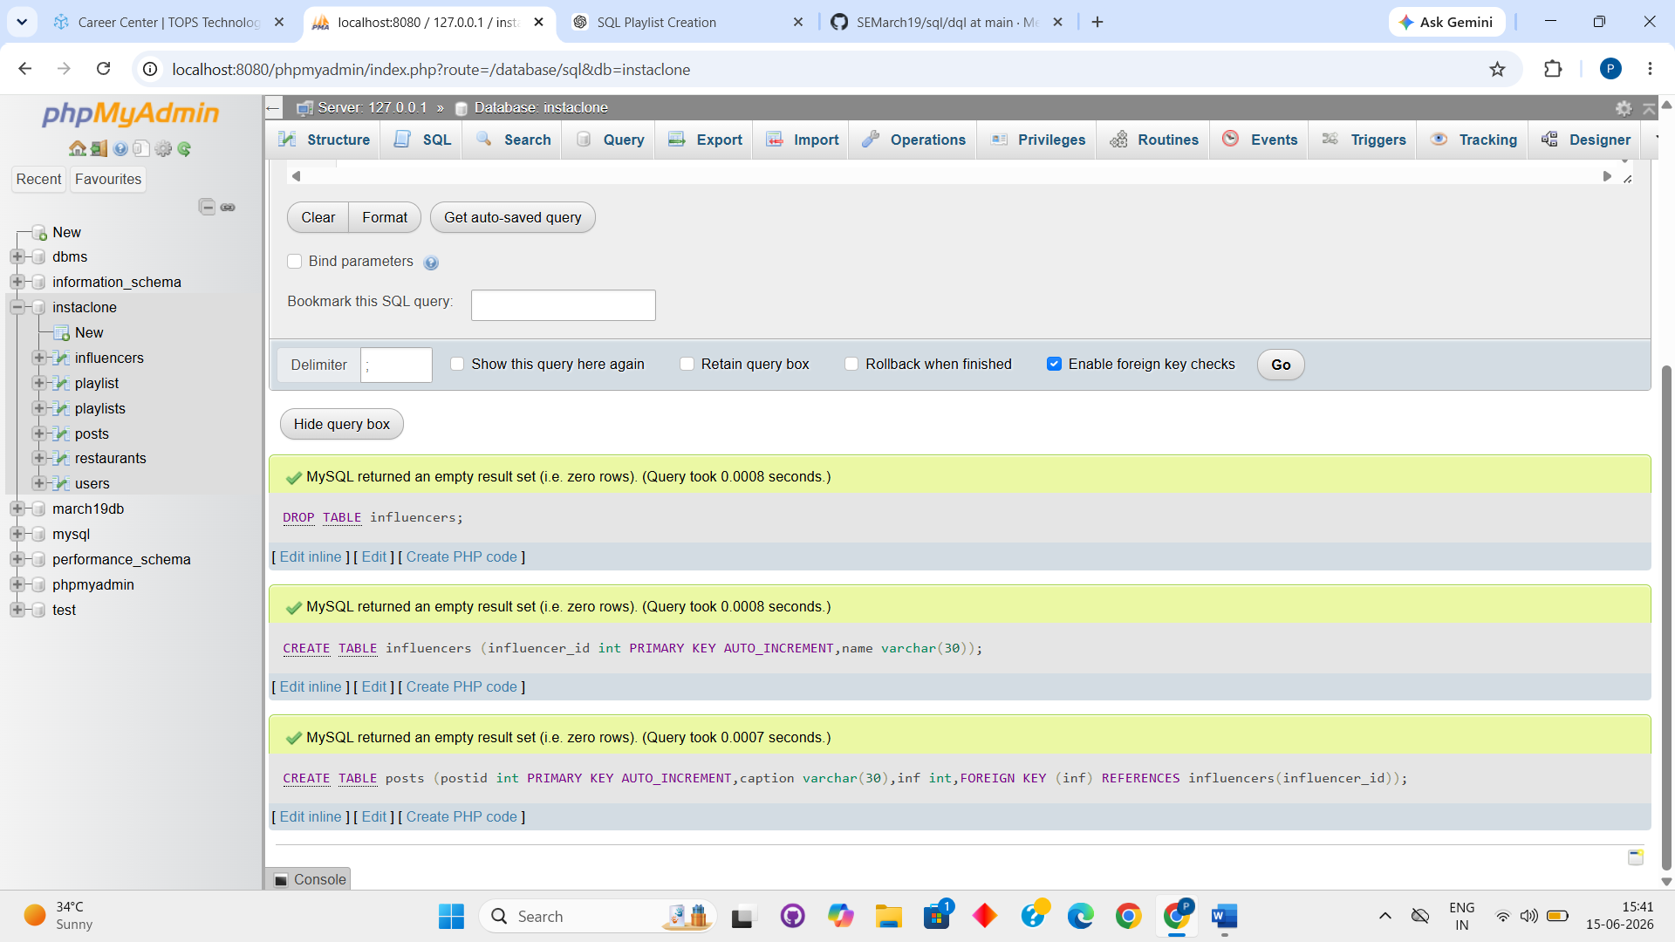

INSERT INTO influencers (name) VALUES
('Aman Sharma'),
('Priya Patel'),
('Rohan Mehta');

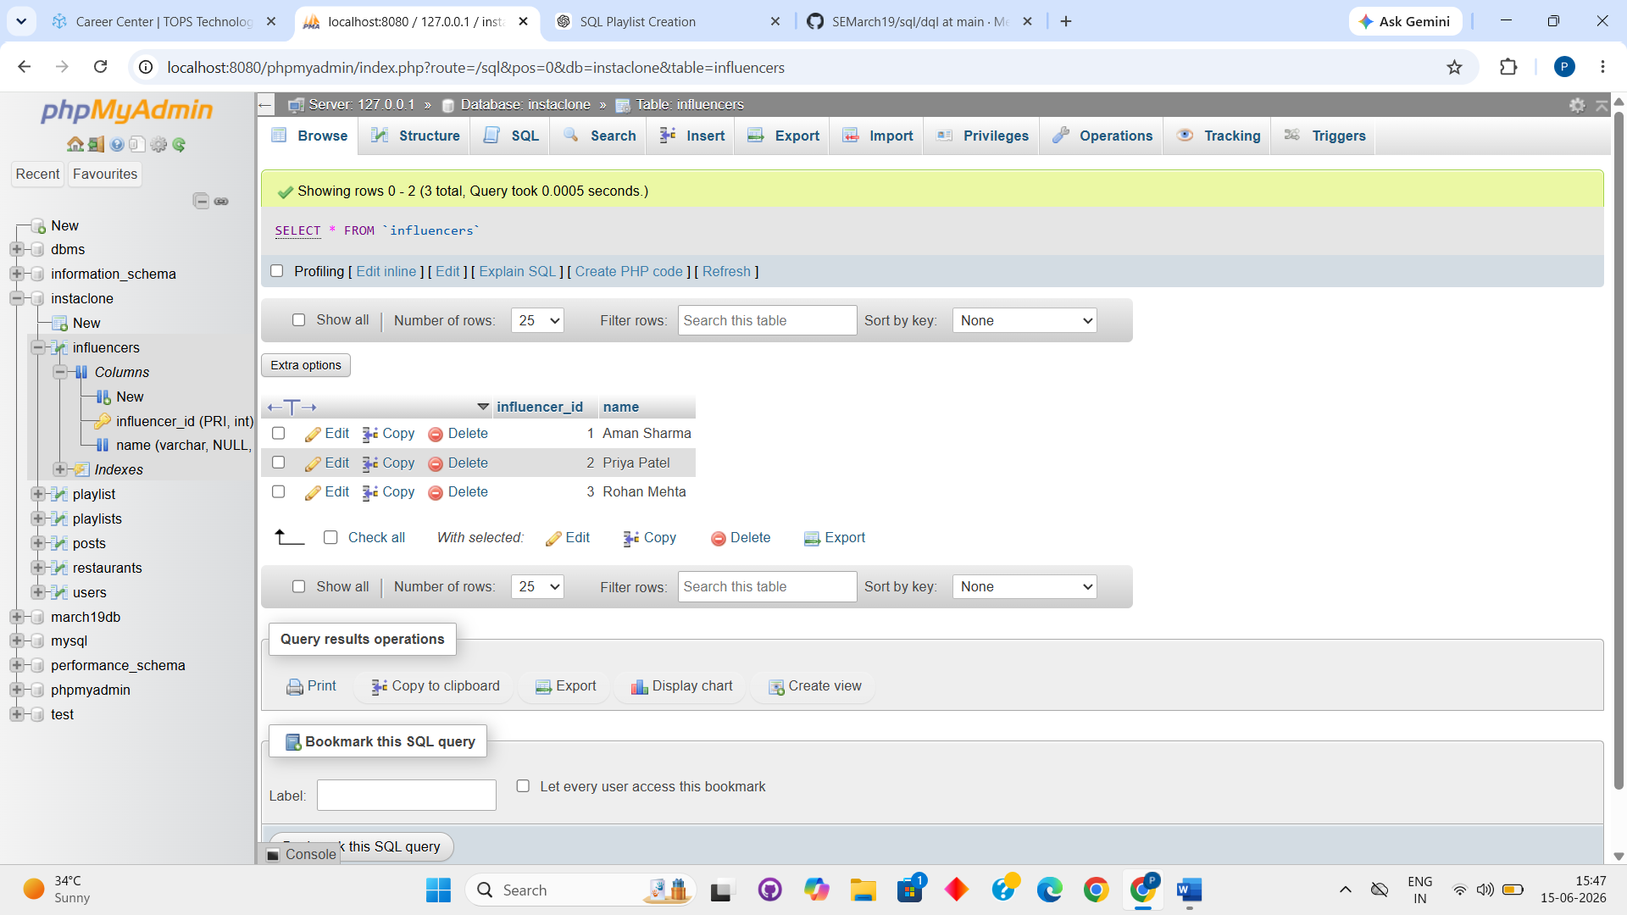

INSERT INTO posts (influencer_id, caption) VALUES (1, 'Good morning everyone!'), (1, 'Check out my new video!'), (2, 'Love this place!'), (2, 'New blog post is live!'), (3, 'Feeling great today!'), (3, 'Try this amazing recipe!');

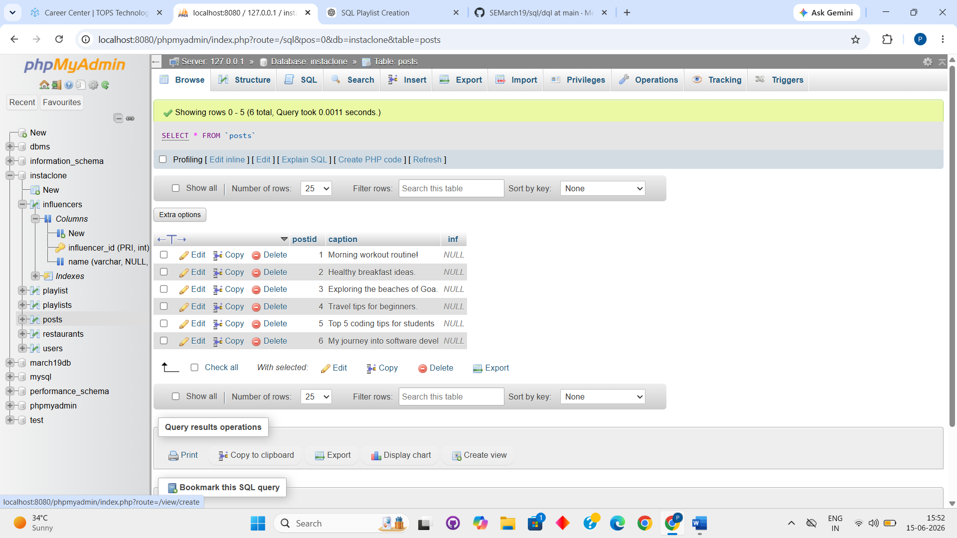

SELECT name, caption FROM influencers INNER JOIN posts on influencers.influencerid = posts.influencer_id;

SELECT name,IFNull(caption,'No Posts') FROM influencers LEFT JOIN posts ON influencers.influencerid=posts.influencer_id;

SELECT name,caption FROM influencers RIGHT JOIN posts ON influencers.influencerid = posts.influencer_id;

